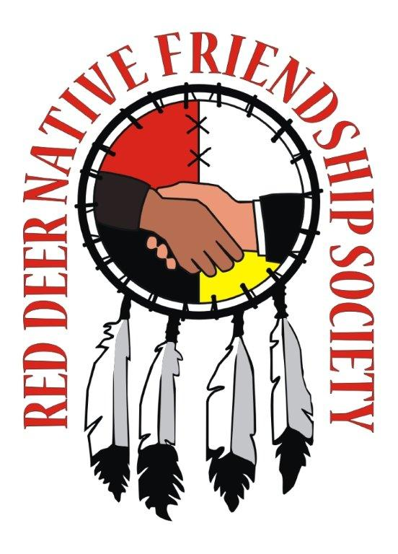
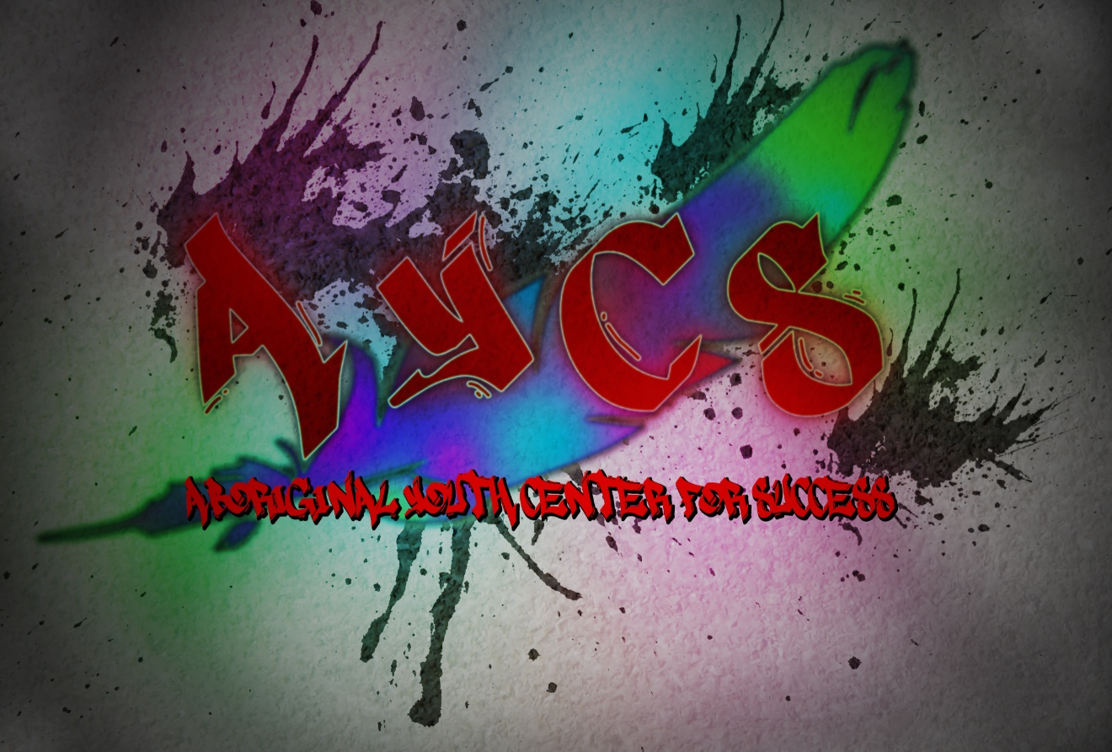
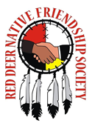

Red Deer Native Friendship Society
4808 51 Ave
Red Deer Alberta
www.rdnfs.com
403.340.0020

April 2014 – March 2015
Annual Report
Table of Contents

Executive Summary
President’s Message
Executive Director Report
Operational Overview

Programs & Services Review
Core Business
New Initiatives

Organization Excellence
Volunteers
Community Membership
Looking Forward to 2015-2016

President’s Message

President’s Message:

The past year has been a busy one! While we have struggled with maintaining board membership for much of the year, we now have a full complement of board members. Thank you to everyone who assisted in the recruitment of new board members.

The RDNFS continues to work hard on advancing the Asooahum Centre and affordable housing development. There have been significant challenges. While we have missed the initial “ground breaking” date, construction could begin as early as the fall. The work of Tanya Schur, Grace Architecture, and Timcon Construction have mitigated many of the setbacks faced by RDNFS.

During the past year, there has been a significant growth in the programming inventory offered by RDNFS. We have introduced the Cyber School to help students with an alternative to traditional education. While the SCcyber Program is still developing, services have been delivered to 7 students ranging from grade 9 to 12. The goal is to provide services to 10 part time and full time students beginning in September 2015.

We continue to actively support our program participants through the Aboriginal Housing Support Program, the Housing Outreach Program, and Four Directions Family Support programs. Additionally, the RDNFS maintains many community support programs such as: Women’s Wellness, Little Paws, Wellbriety, Craft Circle, and Thunderbird Learners.

A lot of work has gone in to brining the “Walk for our Sisters” and “I am a Kind Man” awareness campaigns to the RDNFS and Red Deer. A big thank you to all the staff who have taken strong leadership roles on new and developing initiatives!

In friendship,

Darren Tootoosis
Board Chair

Executive Director’s Report

Dear Community Members:

I am fortunate to work with such an amazing team of staff at the friendship centre committed to the vision of an empowered community without need. Although I have the title of Executive Director we all share the leadership of our Centre and share the responsibility of serving you, our members. This year I have seen leadership growth in all the staff but I am especially indebted to Nadette Agecoutay who has taken on much of the leadership of our centre. With funding from United Way we opened the Aboriginal Youth Centre for success under the direction and guidance of Jim Moreau. He has become a valuable part of the Leadership Team.

Countless volunteer hours have been logged by the board, community volunteers and the Asooahum Advisory group. Rodney Soonias has sat on the Asooahum joint steering committee since 2012. This community and the elders have held the vision for a cultural centre for a very long time and I am so happy that we were able to sign the title transfer to 3.1 acres of land at 4615 in Riverside Drive in November of 2014. The housing development and culture centre continues to move forward in “glacial time” but we remain optimistic that this much needed housing will be completed in 2015-2016.
All of our programs are bursting at the seams. It is a privilege to be part of a team of 12 fulltime and 2 part time staff. During our morning stand up ceremony I often think of our former Executive Director, Sheralle, who rebirthed the current RDNFS mission with only herself and an assistant. The support of the community has made it possible for us to become what we are today. We are all related-interdependent. In the community, “the honour of one is the honour of all and the pain of one is the pain of all”. I like that quote. It keeps me getting up in the morning and praying hard for the strength to buffalo on building community and creating opportunity for others to join together and become a proud community.This year the board and staff “recast the vision”. It is bold and audacious.
“ In the spirit of friendship, the RDNFS is committed to an empowered community without need. We embrace and are guided by cultural wisdom and traditional teachings to provide a health and safe place of belonging for all people living in Red Deer”.

We can’t do this without you, the members. There will be tremendous need and opportunity for you to be involved in the realization of the vision of Red Deer Native Friendship Society in the coming year. We welcome and encourage your participation.

In Friendship,

Tanya Schur
Executive Director
Operational Overview

The RDNFS is a charitable Aboriginal agency dedicated to building an empowered community through Asooahum cultural housing, community development and the Aboriginal Youth Centre for Success. We are awakening Aboriginal cultural teachings and family preservation services that promote wellbeing and assist with the adjustment to life in Red Deer. We strive to extend friendship and foster positive relationships to bring awareness of Aboriginal people and culture to all citizens of Red Deer.

This year marked the 30th year anniversary of Red Deer Native Friendship Society. The biggest effort expended in 2014-2015 was the completion of the title agreements on the housing development land. We continue to seek enhanced funding to complete all three phases of the project in 2015-2016. We had a project coordinator working with us for half the year.

In partnership with SCcyber we opened the SCcyber high school program with 5 students and with the successful completion of the pilot we look forward to expanding our program to 10 students in September of 2015. We received funding from Urban Partnerships and have been able to add employment services and cultural programming for youth in AYCS.
Nova Chemicals helped up renovate the kitchen so we can use the space as a meeting/counselling space for the youth program.

We are providing more supervised visits for families dealing with CFS. We will need more funding if we are to continue this important service. We are working hard to strengthen our relationship with CFS workers to ensure that our families have all the tools they need. We continue with in home parent coaching and summer cultural programs. Accreditation was completed for both the 4Directions Family Support program and the Aboriginal Housing Program. We also complete an evaluation of the Aboriginal Housing Program and had opportunity to share the results of that evaluation at the Seven Cities Housing Conference.

We have signed another rental agreement for our current location and hope that we will be able to move to the Asooahum Friendship Centre by 2017. We have formed a capital fundraising committee to begin fundraising for that project.

RDNFS has been chosen by COADY Institute to do some organization and community development. The board and staff will have opportunity to do capacity building with the Institute as we develop the operational plan for the Asooahum Crossing. The Executive Director will continue to participate on the First Nations Women’s Council provincial task force.

Core Business, Goals & Activities

Core Business #1 | Capacity Building and Financial Sustainability
Goal 1: Maintain long term sustainability in both Operations and Financial Management.
Goal 2: Build Capacity by increasing training opportunities in Core Operations.
Goal 3: Build a place of belonging and sanctuary for our membership and offer culturally sensitive supports and services.
Goal 4: Increase capital and operational funding.

Annual Activity Report

Goal #1 was accomplished by remaining transparent and accountable to our community, our funders, and our membership through accurate and timely financial reporting and audited yearend financial statement and annual report. Our AGM was held at Kerry Wood Nature Centre in September 2014. Operational excellence in programs is assured by the Program Director and AYCS Director who review program goals and manages program budgets. Weekly program staff meetings ensure programs are remain on target with workplans.

Goal #2 was accomplished by providing core staff the opportunity to participate in organizational strategic planning in collaboration with COADY Institute. We participated in the Urban Aboriginal Voices Community Consultation in March and continue to attend community meetings and collaborate on local events.

Goal #4 was addressed through CCS organizational assessment was completed and core funding increased. A number of new partnerships have been developed to support the programming of the AYCS. Accreditation of 4Directions Family Support and Aboriginal Housing program was completed. RDNFS has the first accredited housing program in Red Deer.

Asooahum Cultural Centre and Housing Development
.
On November 14, 2014 we signed the title transfer to 3.1 acres of land at 6415 Riverside Drive. Negotiations will continue for the land swap value difference from the Clearview site. Grace Achitecture was hired as the architect and project coordinator and Timcon Construction will be our General Contractor. Designs were developed in collaboration with the community. The joint steering committee will continue to meet on a quarterly basis to keep the project moving forward through the permitting process.

Core Business, Goals & Activities cont…

Core Business #2 | Cultural Awareness
Goal 1: Promote opportunities to make cultural and spiritual connections for Aboriginal Community members and all citizens of Red Deer
Goal 2: Increase the public image of Red Deer Native Friendship Society and our services and programs

Annual Activity Report

Drop In Centre and Friendship Night
This year we facilitated more Aboriginal Awareness workshops for other agencies, creating greater awareness of Aboriginal culture and history. As part of the housing program a Friendship Night with potluck dinner was offered. The youth hosted the Elders and youth lunch potluck once a month. Many students from treatment centres attended. We continue to provide “the Blanket Exercise” and talking circle about residential school impact for the Red Deer Housing Team.

Aboriginal Community Events-30th Anniversary Round Dance

As part of 30th year anniversary we hosted a roundance at Lindsay Thurber High School. Over 300 people attended. We provided Metis Local with support for their Blackfalds event on National Aboriginal Day and partnered with Red Deer Aboriginal Employment to host a community picnic in Red Deer for National Aboriginal Day. The event included the first annual tipi raising completion, bannock over the open fire and a BBQ for community members. We participated on the organizing committee for the Red Deer and Community District Museum to begin planning for the Walking with Our Sisters Installation which will be hosted at the Museum in June of 2015.

Eldership Community Program

We did not receive funding from New Horizons this year but hired an elder part time wot work with the Housing Program. We continue to host the Elders craft circle on Fridays and partnered with the Outreach school to provide elders talking circles for students of AYCS and the Outreach School. We began sponsoring the Women’s sweat every other month and providing cultural connections to our housing participants.

Core Business, Goals & Activities cont…

Core Business #3 | Housing Support and Homelessness Prevention
Goal 1: To provide accessible, affordable housing to Aboriginal people in Red Deer.
Goal 2: To provide supports and services for individuals to maintain housing and access basic needs.

Annual Activity Report

Goal #1 was achieved with continued funding for the Aboriginal Housing program providing housing support for up to nine months for families and individuals that have experienced episodic homelessness and wish to maintain a path of sobriety. This program was created in response to the growing number of Aboriginal people experiencing a cycle of homelessness and unable to access cultural support within other housing programs. Wellbriety is offered as part of the cultural support for this program. We have offered Medicine Wheel and 12Step for the past four years.

Goal #2 entailed providing short term assistance and housing skill development through monthly lifeskills workshops such as “homefulness”, budgeting and money management, basic computers, and human rights-landlord tenant rights. The cultural resource worker provides cultural support and mentorship to those involved in the housing program. Both of these programs continue to be funded through the City of Red Deer.

We continued to work toward the completion of the Aboriginal Affordable Housing Initiative in partnership with the City of Red Deer to build 32 units of affordable housing for Aboriginal people. We participate with the Joint Housing Committee and also have a leadership roll in the Housing Domain of the UAVS.

Core Business, Goals & Activities cont…

Core Business #4 | Community and Family Supports
Goal 1: Support Family Unity.
Goal 2: Provide teachings of the Medicine Wheel and nurture cultural pride.
Goal 3: To increase the number of Aboriginal families and individuals accessing appropriate health care resources
Goal 4: To provide support and advocacy to families working with CFS

Annual Activity Report

Core Business #4 entailed offering a culturally relevant parenting program through in home parent coaching. In home meetings opened the door to conversations and skill development one on one, once a month traditional parenting workshops, the Little paws toddlers program, and family support and counseling with the NFC social worker.

To build parenting skills and prevent children from being apprehended by Child and Family Services. We implemented in-home parent coaching and monthly traditional parenting workshops. The framework of this program was the medicine wheel teachings as a way of life and traditional parenting teachings to promote the healthy well-being of children, families and individuals while focusing on all directions of the Medicine Wheel in order to sustain and nourish Aboriginal culture. Lessons were taught by the Cultural Family Educator and the Family Support worker with assistance by community facilitators and local elders.

The Health Liaison provided weekly women’s wellness program and brought in many facilitators to cover topics identified by the participants. We were able to work with The Green Clinic to provide a number of natural medicine workshops over the year. The community nurses from the diabetes Association provided one-on-one diabetes counselling once a week.

Community partnerships that assisted with the achievement of this goal were our local elders circle and Native Counseling Services and Central Alberta Child and Family Services. We formed a partnership with Central Alberta Sexual Assault Clinic to provide counselling at the Friendship Centre once a month.

Core Business, Goals & Activities cont…

Core Business #5 | Youth Program- SCcyber school
Goal 1: To provide opportunities to increase youths’ social, economic, and personal prospects.
Goal 2: To provide youth opportunity to complete their high school diploma

Annual Activity Report

Core Business #5 entailed implementing the Aboriginal Youth Centre for Success. We received a small amount of funding from United Way to hire a program director to develop the Centre for Success and start the SCcyber program. We signed a partnership agreement with SCcyber to pilot a satellite program at the AYCS. In the first semester we had 5 students enroll in the program. In January we received enhanced funding from UP and hired additional staff to implement youth activities night and the Aboriginal Youth Council.

It has been difficult to reengage the youth due to inconsistency of program funding that jeopardized our ability to create stable support for our youth. A facebook site and website was developed to attract new youth to the program. Partnerships have been created with Red Deer Public School District to provide a tutor to assist high school students with course work.

Community partnerships that assisted us to achieve our goal were the Red Deer Food Bank, Boys and Girls Club of Red Deer, Youth and Volunteer Centre of Red Deer, National Friendship Centres Association and our principal funder Aboriginal Affairs Northern Development. The ANFCA provided many training opportunities for our youth to enhance their personal prospects.

New Initiatives

New Initiative #1 | Aboriginal Youth Centre for Success-
Goal | To assist youth 14-21 with opportunity to complete high school diploma through SCcyber, Spirit Seekers youth programming and path to Employment
New Initiative | Aboriginal Youth Resource Centre

Annual Activity Report

The Aboriginal Youth Centre for Success was designed to provide youth 14-21 with a safe place to develop self-confidence, increase cultural identity and reduce barriers to economic participation. From January to March 2015 the Youth Program Director and the SCcyber mentor worked with youth to recruit youth and promote leadership development by establishing the Youth Council.

Youth were able to participate in ANFCA leadership development training in Edmonton. The new youth worker was trained in case management using the Youth Outcome Star and spent the first quarter of the year developing the program and strengthening partnerships for AYCS and the cyber school.

Organizational Excellence

Our Volunteers:
Community volunteers are an important asset to Friendship Centres; the hours they dedicate to our Friendship Centre demonstrate the great level of support for and appreciation of our services that we have in our community. Their time and efforts assist with program/service delivery, provide guidance to Friendship Centre Board and Staff and contribute to successful special events. Included among our volunteer numbers and volunteers’ annual hours of service are the committed members of our Board of Directors.

Number of Volunteers | Approximate Annual Volunteer Hours
45 | 1000

Membership:
Total Number of Friendship Centre Members as of March 31st, 2015 | Total number of Friendship Centre Board Members as of March 31st, 2015
115 | 6

Reflection & Looking Forward

Highlight of the Past Year:
In 2008 Red Deer Native Friendship Society, the City of Red Deer, and the Province of Alberta began negotiations to fund 16 units of housing in Clearview Ridge. In 2012 the City of Red Deer did not approve the rezoning application. As a result a process was developed to identify an appropriate site to develop 16 units of low rise affordable housing and another 16 units attached to a Cultural Centre. In November 2014 RDNFS signed the title transfer of 3.1 acres for the development of the Asooahum Crossing. Our organization has continued to grow, adding the Aboriginal Youth Centre for Success. This program will provide a sustainable youth program with partnerships developed with United Way, Red Deer Public School District, SCcyber and Boys & Girls club.

We have engaged the staff, board and community in strategic planning and have been instrumental in the community consultation for Urban Aboriginal Strategy.
Main Challenge of the Past Year:
With our increased growth greater demands have been placed on the Executive Director, Program director and AYCS director. We posted for a new Executive Director to enable the ED to move to the position of Asooahum Project Coordinator but were unable to hire. We will continue to seek funding for a full time Asooahum project coordinator.

We will continue to focus on sustainability and future economic development to support the growth of the organization once we move to the new centre.

Planning ahead for each year is important to our Board of Directors and our Management. Monitoring our progress throughout each year is integral to our success.

This is our Centre’s Main Focus for the 2015-16 Year:
The organization must turn its focus toward an organizational assessment and redesign to include exploration of Social Enterprise and management of the 32 units of housing. Part of organizational restructuring will include the operational model for the programs currently being offered by RDNFS.
This process will include community consultation and work with a business consultant to assist the Board with strategic planning for the future.

The business plan incorporates the community feedback, environmental changes, and provides the details necessary to realistically respond to community need and address challenges on an annual basis. We will use the 2014-2020 Business plan to guide our program development and financial needs. Our board training and strategic planning sessions will determine the strategic direction for the Friendship Centre in coming years and will be the guiding document for the business plan.

This year our strategic planning was facilitated in partnership with Coady Institute. The facilitator from Coady helped the organization complete Asset Based Community Development beginning with asset mapping the staff and board to identity organizational strengths and opportunities. The new vision and mission statements were completed to include the Asooahum community housing program.

